

本科实验报告

课程名称： | 数字逻辑设计
姓 名： | 王俊
学 院： | 海洋学院
专 业： | 海洋工程与技术
学 号： | 3170100186
指导教师： | 蔡铭

2019年 10 月 22 日

浙江大学实验报告

课程名称： 数字逻辑设计 实验类型： 综合
实验项目名称： The basic principle of latches and flip-flops
学生姓名： 王俊 专业： 海洋工程与技术 学号： 3170100186
同组学生姓名： 指导老师： 蔡铭
实验地点： 东4-509 实验日期： 2019 年 10 月 22 日
一、实验目的和要求
1.1. Master the conditions and working principle of the latch and trigger
Master the difference between a latch and a trigger
Master the basic functions of the basic SR latch, gated SR latch, D latch, SR latch, D flip-flop
Master the timing issues of basic SR latches, gated SR latches, D latches, and SR latches
experiment apparatus:
- 1 computer with Xilinx ISE 14.7
- SWORD development board 1 set
Experimental Materials：
No

Experimental task：
Task 1: Implement basic SR latches, verify functions and existing timing issues
Task 2:Implement gated SR latches and verify functionality and timing issues
Task 3:Implement D latches and verify functionality and timing issues
Task 4:Implement SR master-slave triggers and verify functionality and timing issues
Task 5:Implement D triggers and verify functionality

二、实验内容和原理
- Experimental principle：
- Sufficient conditions for constructing the latch
- Can maintain a given steady state for a long time
- There are two stable states: 0, 1
- Under certain conditions, the logic state can be changed at any time, that is, set to 1 or set to 0.

The most basic latches are: SR latch, D latch
The latch has two stable states, also known as a bistable circuitMultiple selector bit extension:

- SR latch (1) using or nor2:
The output of two reverse logic devices with 2 inputs is cross-connected with the input, and the other input is used as an external information output to form the simplest SR latch.
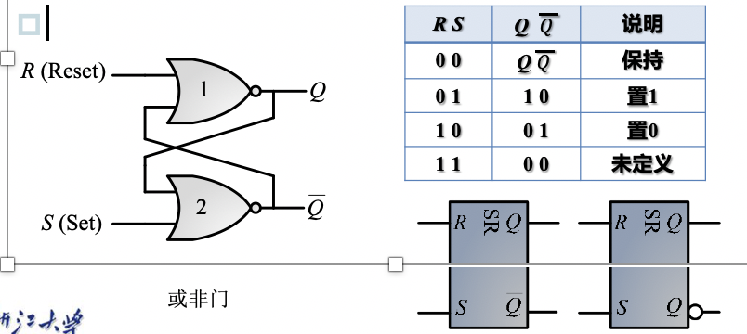
- SR latch (2) using nand2:
The output of two reverse logic devices with 2 inputs is cross-connected with the input, and the other input is used as an external information output to form the simplest SR latch.
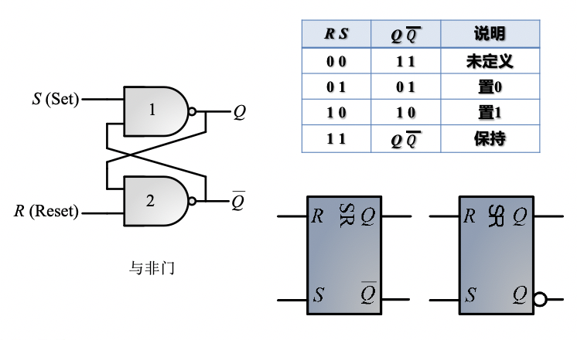
Gated SR latch:
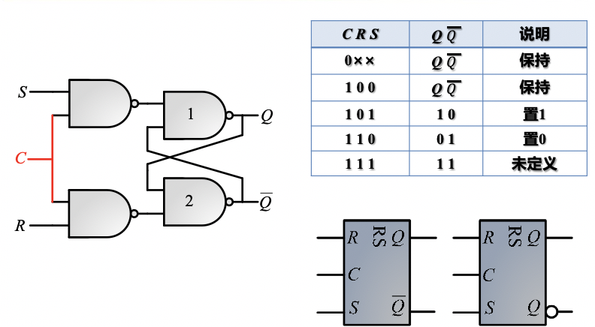
Disadvantages of Basic SR Latches: Uncertainty
Solution: Eliminate uncertainty
Requires only one data input D /Output Q is equal to input D /Use level control C
- D-Latch:
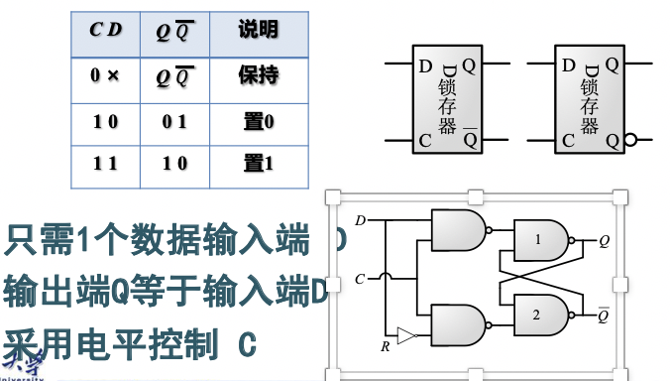

Disadvantages of the D latch: there is a flip phenomenon-if the D latch is used directly in a sequential circuit as a state storage element, when the enable control signal is valid, it will cause the state value of the element to change at any time, Instead of maintaining the required original state value
Solution: Eliminate the phenomenon of flip, so that the internal state of the latch is changed only once per trigger
Trigger: the momentary state when the state of the latch is changed by an external input
Trigger: a latch circuit that changes the state only once per trigger on the basis of a latch (bistable)
- Triggers:
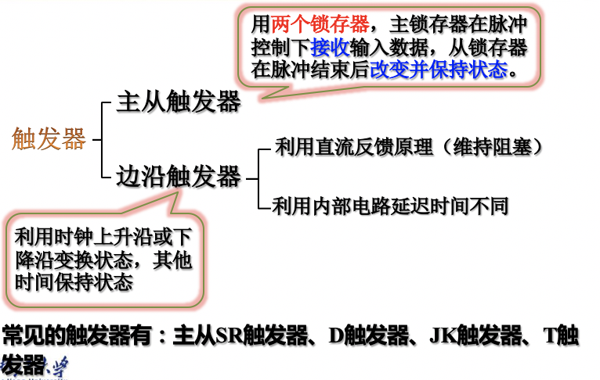
- SR ms trigger:
Consists of two gated S-R latches in series, the clock of the second latch is inverted by the inverter
When C = 1, the input signal enters the first latch (master latch)
When C = 0, the second latch (slave latch) changes the output
The path from input to output is interrupted by different clock signal values (C = 1 and C = 0)
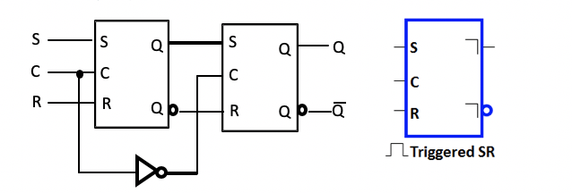

- Positive edge-maintaining blocking D flip-flop:
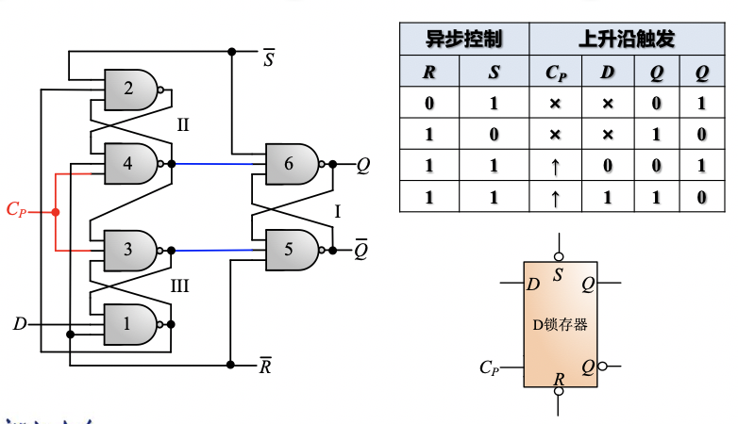
- 实验过程和数据记录
Tasks:
Implement basic SR latches, verification functions and timing issues
Implement gated SR latches and verify functionality and timing issues
Implement D latches and verify functionality and timing issues
Implement SR master-slave triggers and verify functionality and timing issues
Implement D triggers and verify functionality

Task 1: Data Selector Design
3.1.SR (nor \ nand)
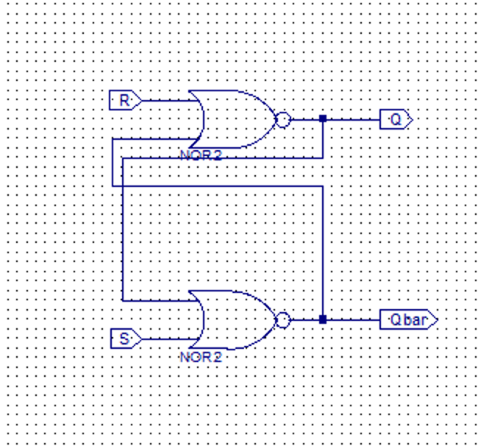
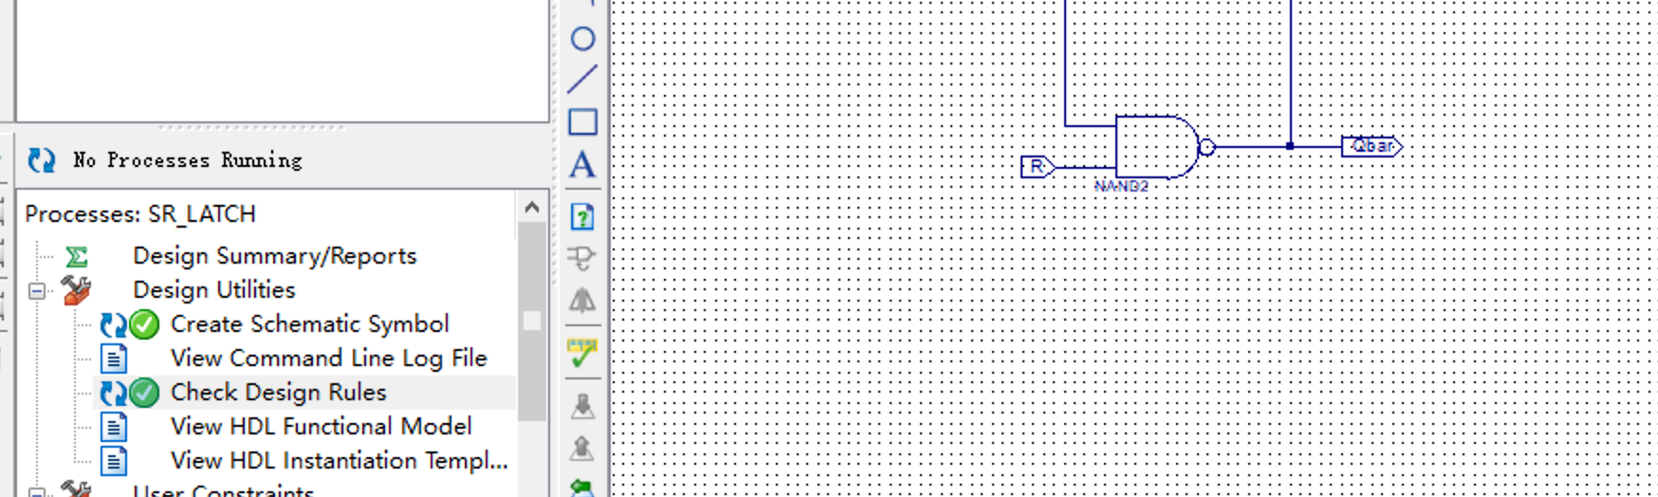

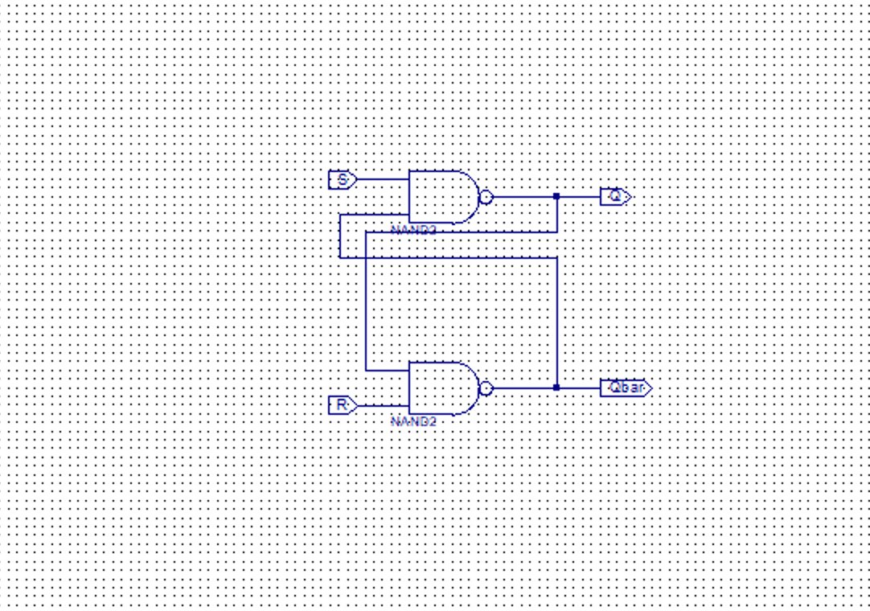
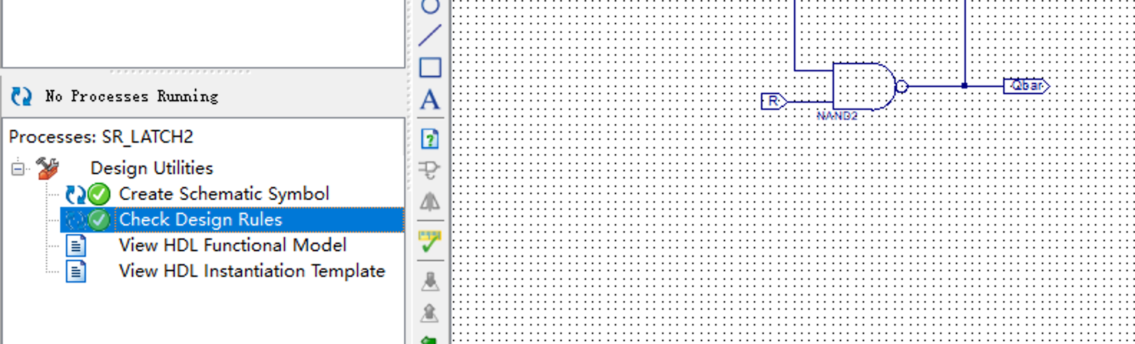
3.2.D_Latch:
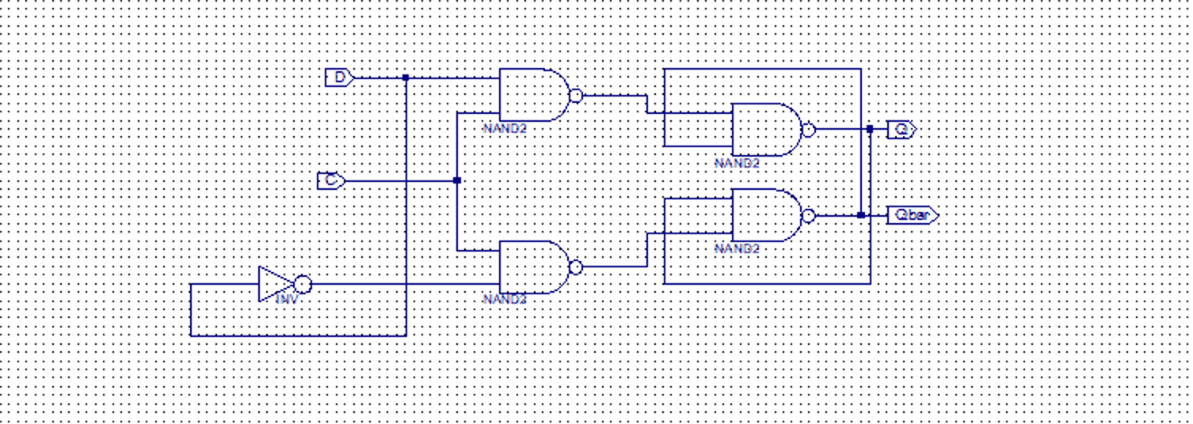
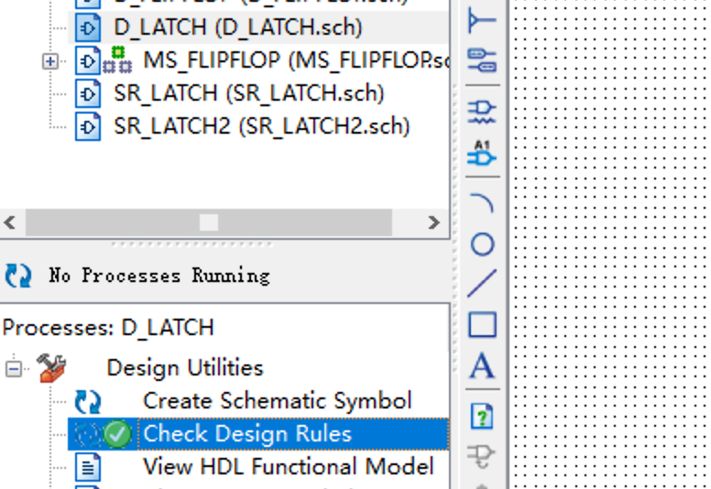
3.3.CSR_LATCH:
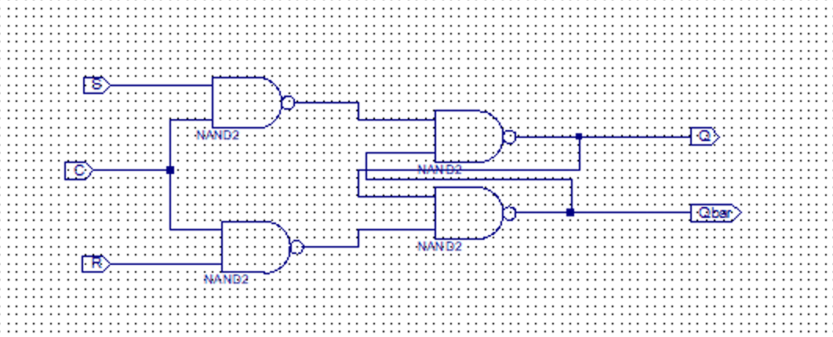
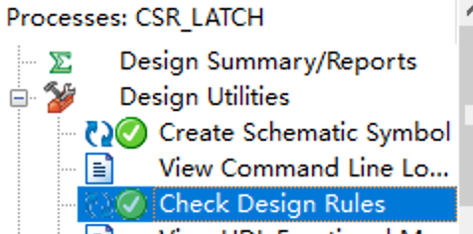
3.4.MS_FLIPFLOP
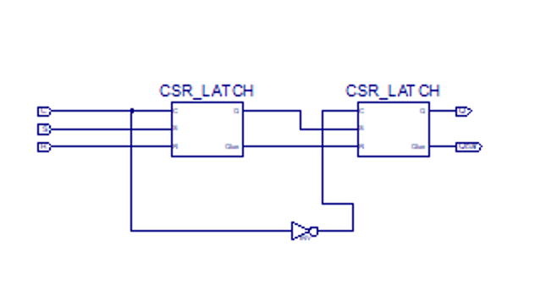

3.5D_FLIPFLOP

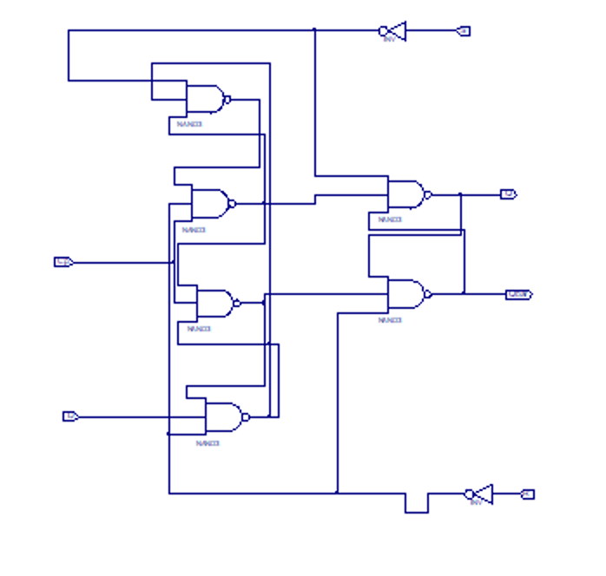
- 实验结果分析
- SR(nor):
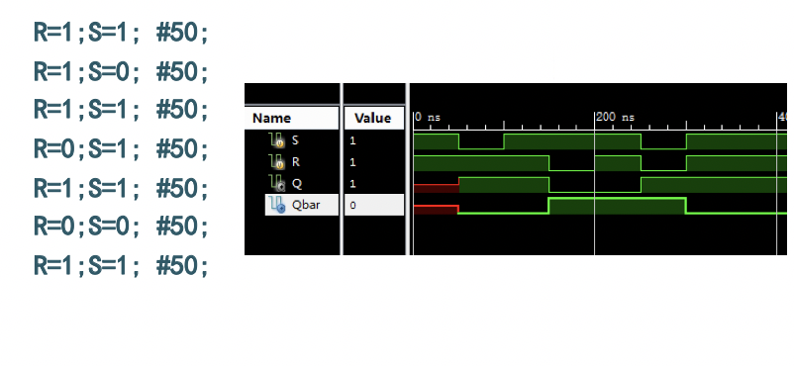
Mine:
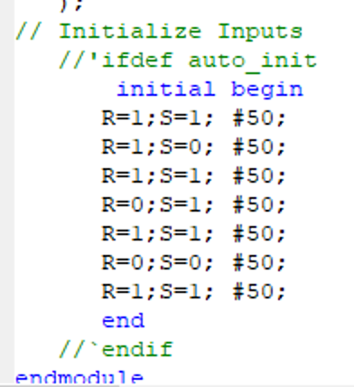
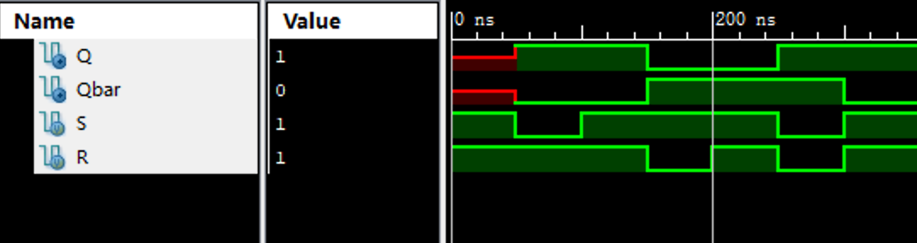
The simulation uses Multisim SE 10.4, so the timeline is not on the upper part but the bottom.
And the time unit is ps, which is 0.001ns
In 0-50ns, The Q does not have an initial state.
In 50-100ns, S=0 so the Latch is SET, Q=1 and Qbar=0
In 100-150ns, the state is hold.
In 150-200ns, R=0 so the Latch is RESET, Q=0 and Qbar=1
In 200-250ns, the state is hold
In 250-300ns, S=0 and R=0, the latch entered the undefined state of Q=1, Qbar=1,
At 300ns, The flip occurred and the state was changed to one of the valid states, which is
Q=1 here.
After 300ns, the state was hold at Q=1 Qbar=0
- SR(nand):
Mine:
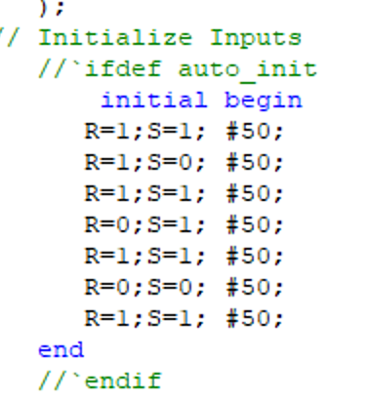
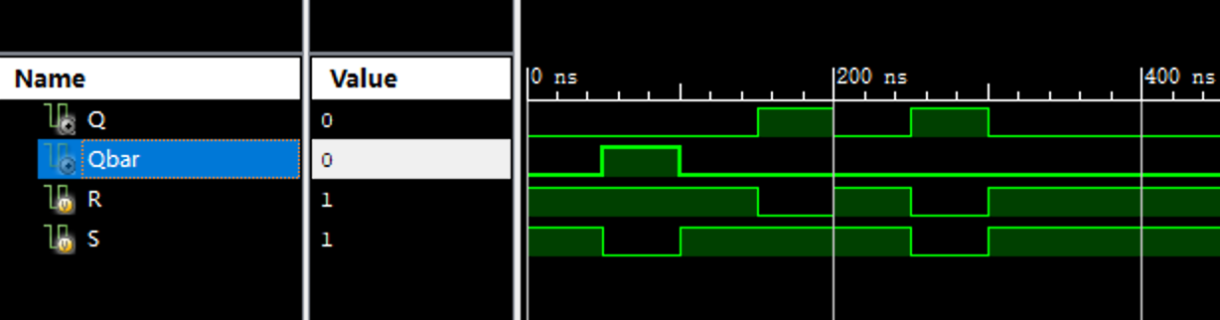
- CSR:

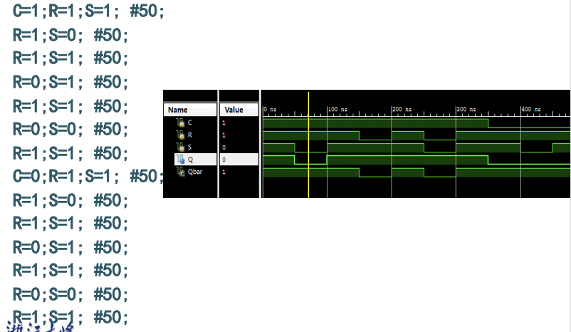
Mine:
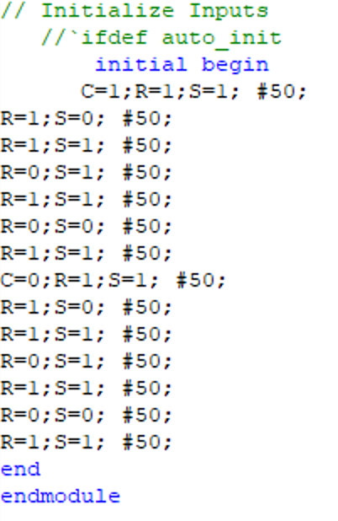
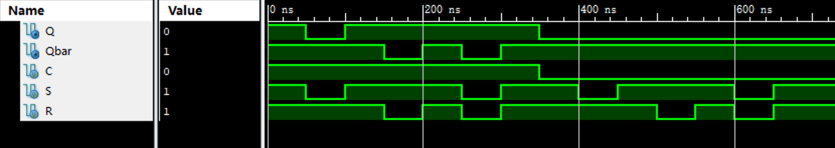
Note that this is NOT the same as the given simulation graph in the PPT
In this time, S, R have to be 1 to be valid.
In 0-350ns, C=1, the latch is “enabled”.
In 0-50ns, 100-150ns, 200-250ns, 300-350ns, R=1, S=1 so it entered the state of
undefined and Q=Qbar=1;
In 50-100ns, only R=1 so the latch is in Reset state so Q=0, Qbar=1.
In 150-200ns, only S=1 so the latch is in Set state so Q=1, Qbar=0
In 250-300ns, S=0 and R=0, so the latch should hold a value. However, at 250ns a flip
occurred so the latch entered one of the two valid states. In this situation, it entered Q=1,
Qbar=0.
At 350ns, the input S, R of the latch were suddenly changed to 1, so it entered a valid state.
Here it goes to Q=1, Qbar=0After 350ns, the S and R is “disabled” by C=0, so no matter what happens to S and R, the
latch remains its state from 350ns.

- D_Latch:
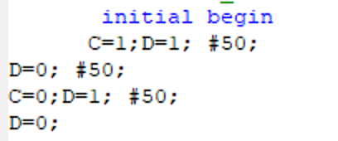
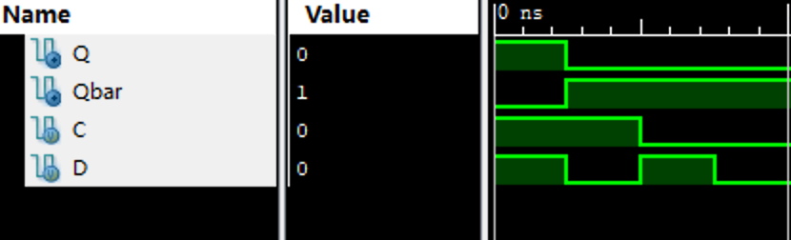
At first, D=1 and it is enabled (C=1) so Q=D=1, Qbar=0.
At 50ns, D=0, so Q changed to D immediately, Q=0, Qbar=1
After 100ns, C=0, so no matter what happens to D, the latch remains its state of Q=0,
Qbar=1.

- MS:
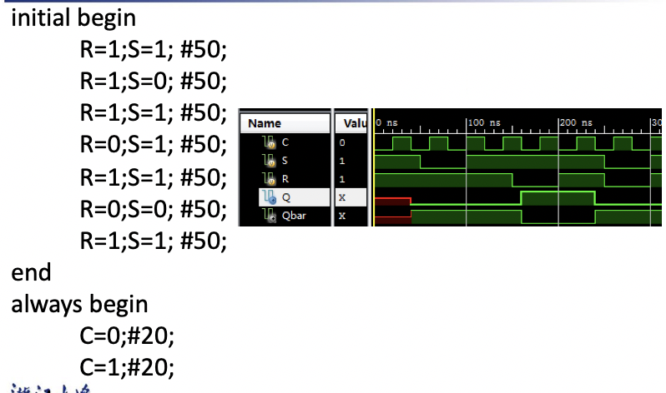
Mine:
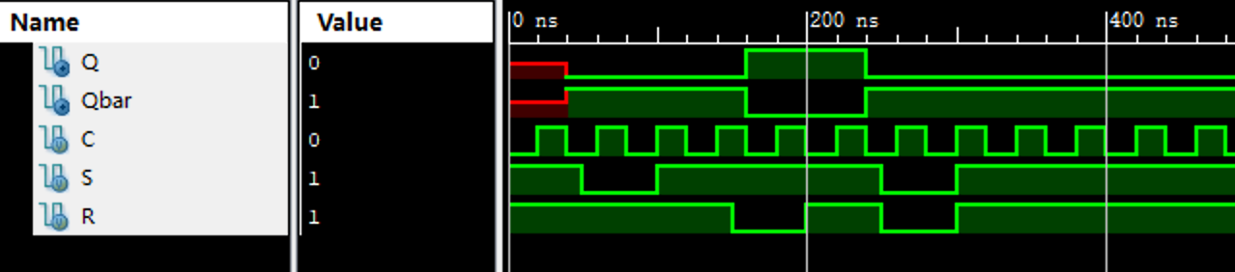
At first, D=1 and it is enabled (C=1) so Q=D=1, Qbar=0.
At 50ns, D=0, so Q changed to D immediately, Q=0, Qbar=1
After 100ns, C=0, so no matter what happens to D, the latch remains its state of Q=0,
Qbar=1.

6.DD:
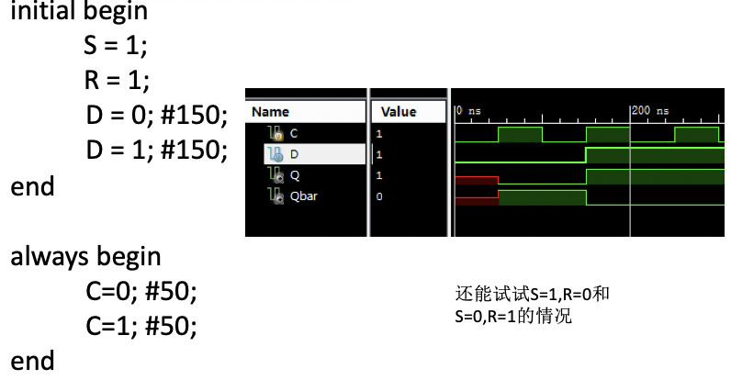
Mine:
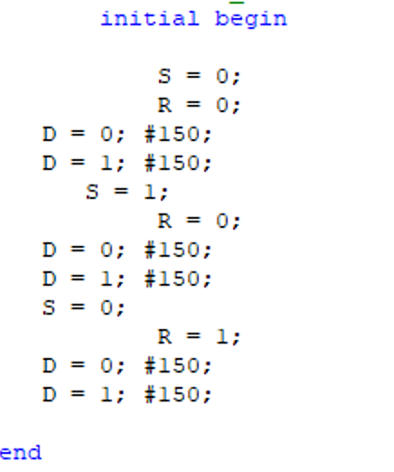
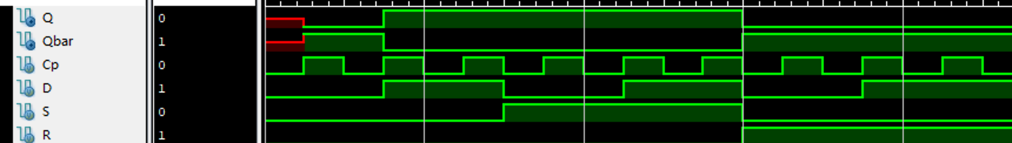
At 0-50ns, no state is stored in it.
At first, D=1 and it is enabled (C=1) so Q=D=1, Qbar=0.
At 50ns, D=0, so Q changed to D immediately, Q=0, Qbar=1
After 100ns, C=0, so no matter what happens to D, the latch remains its state of Q=0,
Qbar=1.

五、实验总结与反思
1. In this experiment, we learned a lot more about the principles of latches and flip-flops and
used computer simulation to see exactly how they works with given input. This enables us to
have a much deeper understanding of latches and flip flops.

